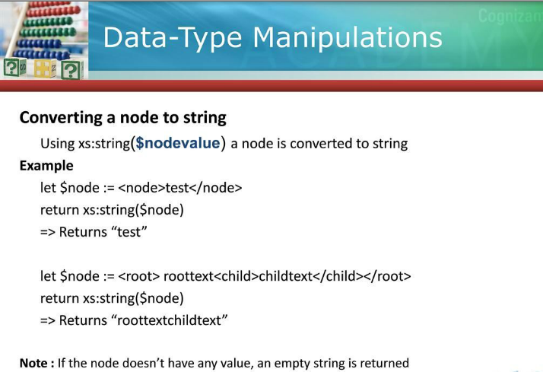

**Example:**

xs:string(<books><book><name>xquery</name><price>100$</price></book></books>)

**Output>**

xquery100$

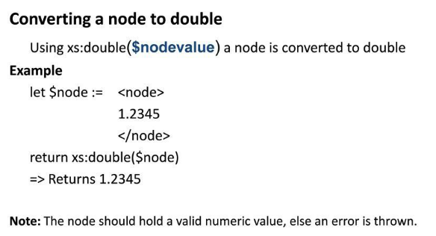

**Note:** If the value of node is a non-integer value then xs:double(..) will throw “**XDMP-CAST: (err:FORG0001)**” exception.

**Example:** xs:double(<books><book><name>xquery</name><price>100$</price></book></books>)

**Output>**

***[1.0-ml] XDMP-CAST: (err:FORG0001) xs:double(<node>xquery</node>") cast as xs:double***

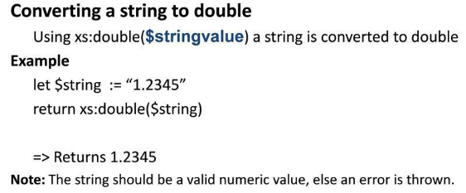

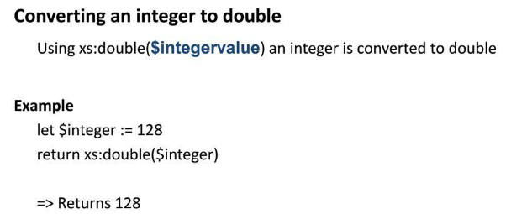

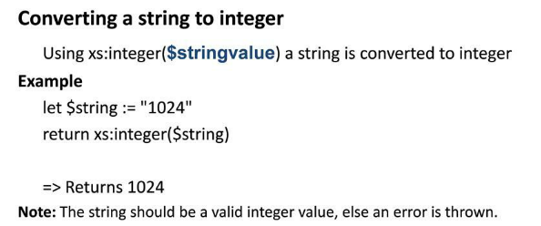

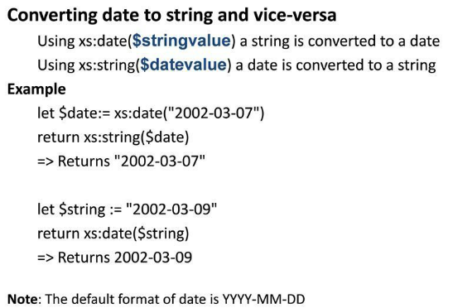



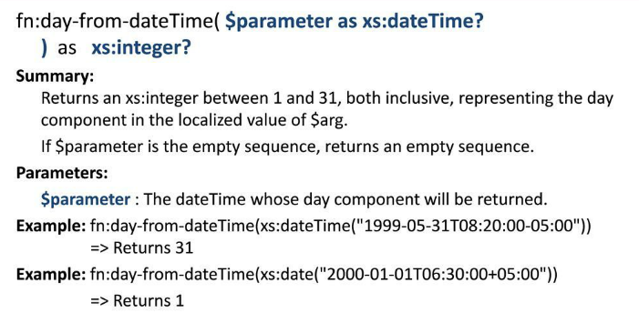

**Example:**  fn:day-from-dateTime(fn:current-dateTime()) //Today is- 2013-05-20T16:58:45.547+05:30

* Return 20

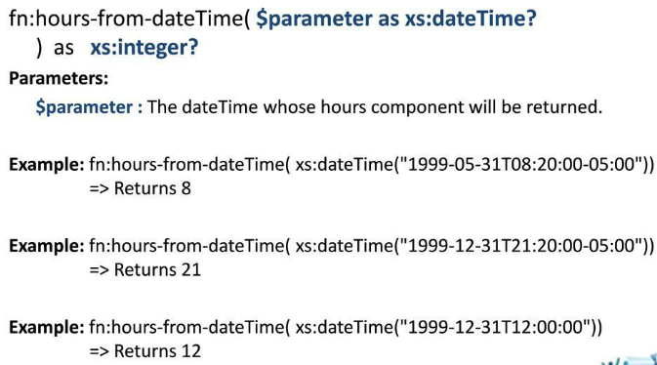

**Example:** fn:hours-from-dateTime(fn:current-dateTime())//Today is- 2013-05-20T16:58:45.547+05:30

* Return 17

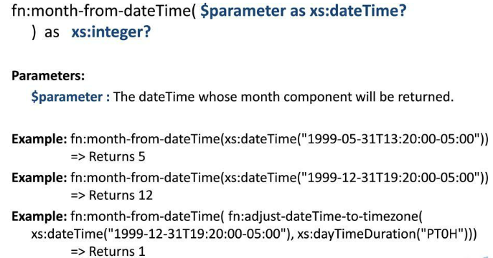

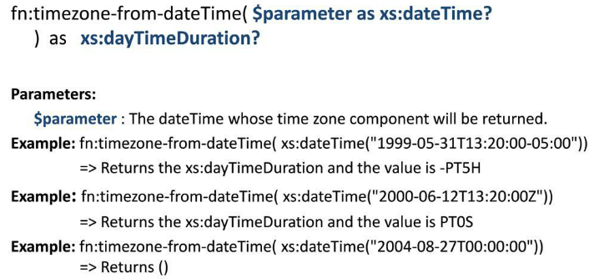

**Examples for all:**

let $currentDate:=fn:current-dateTime()

return

(

fn:day-from-dateTime($currentDate),

fn:month-from-dateTime($currentDate),

fn:year-from-dateTime($currentDate),

fn:hours-from-dateTime($currentDate),

fn:minutes-from-dateTime($currentDate),

fn:seconds-from-dateTime($currentDate),

fn:timezone-from-dateTime($currentDate)

)

* **Returns** 20 5 2013 17 11 34.714 PT5H30M

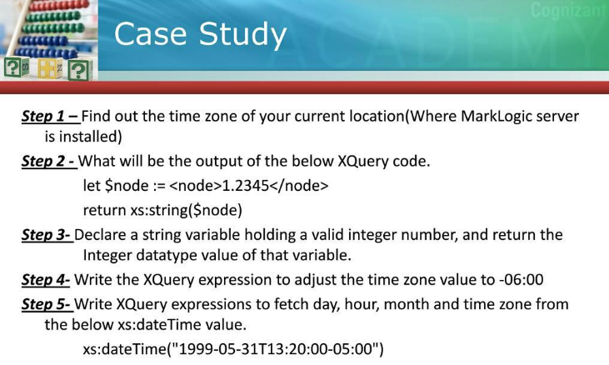

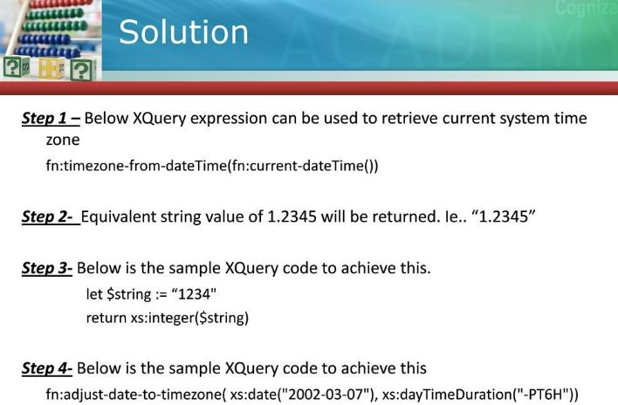

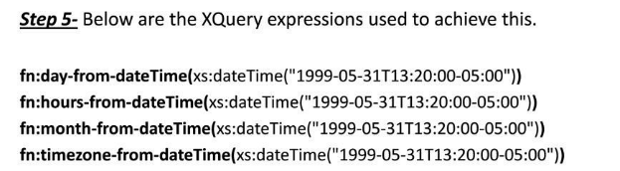

**References:**

<http://docs.marklogic.com/fn/dates>